AIM: Characteristics study of Side Band power and Frequencies in AM using MATLAB.

PROGRAM:

clc;
clear;
close all;

%% Parameters
Ac = 2; % Carrier amplitude
Am = 1; % Message amplitude
fc = 1000; % Carrier frequency (Hz)
fm = 100; % Message frequency (Hz)
Fs = 100000; % Sampling frequency
t = 0:1/Fs:0.05; % Time vector

%% Signals
m = Am*cos(2*pi*fm*t);
c = Ac*cos(2*pi*fc*t);

%% Modulation Index
mu = Am/Ac;

%% AM Signal
am = (Ac + Am*cos(2*pi*fm*t)).*cos(2*pi*fc*t);

%% Demodulation
dem = abs(am);
[b,a] = butter(4,fm*2/Fs);
dem = filtfilt(b,a,dem);

%% FFT
N = length(am);
AM_FFT = abs(fft(am))/N;
f = (0:N-1)*(Fs/N);

%% Sideband Frequencies
USB = fc + fm;
LSB = fc - fm;

%% Power Calculation
Pc = Ac^2/2;
Psb = (mu^2*Pc)/4;

%% Plotting
figure('Name','AM Modulation','NumberTitle','off');

subplot(3,2,1)
plot(t,m)
title('Message Signal')
xlabel('Time (s)')
ylabel('Amplitude')
grid on

subplot(3,2,2)
plot(t,c)
title('Carrier Signal')
xlabel('Time (s)')
ylabel('Amplitude')
grid on

subplot(3,2,3)
plot(t,am)
title('AM Signal')
xlabel('Time (s)')
ylabel('Amplitude')
grid on

subplot(3,2,4)
plot(t,dem)
title('Demodulated Signal')
xlabel('Time (s)')
ylabel('Amplitude')
grid on

subplot(3,2,5)
plot(f,AM_FFT)
xlim([fc-3*fm fc+3*fm])
title('Sidebands')
xlabel('Frequency (Hz)')
ylabel('Magnitude')
grid on

subplot(3,2,6)
bar([Pc Psb Psb])
set(gca,'XTickLabel',{'Carrier','USB','LSB'})
title('Power Distribution')
ylabel('Power (W)')
grid on

%% Display Results
fprintf('Modulation Index = %.2f\n',mu);
fprintf('USB Frequency = %d Hz\n',USB);
fprintf('LSB Frequency = %d Hz\n',LSB);
fprintf('Carrier Power = %.2f W\n',Pc);
fprintf('Sideband Power = %.3f W\n',Psb);

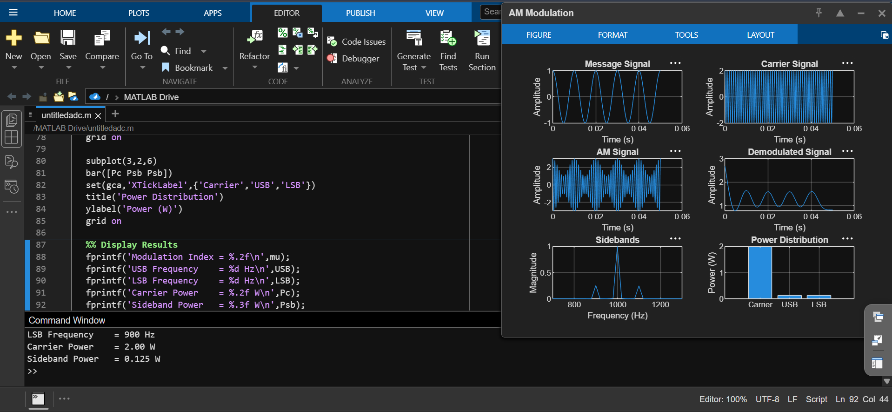

RESULT:
The AM signal was successfully generated and analyzed in MATLAB.

